Volvo Statistics Script Guide

Author: Daniel Elmnäs written 2015-08-12. Last updated: 2015-12-02

Content:

Export Statistics 2

Import Macro 3

Get started 4

CombineFiles () 5

GetColData () 5

myYear () 5

myMonth () 5

CheckInstandCol () 6

CheckNumOfIns () 6

RemIND() 6

RemMLY () 6

MyCompany () 6

NewWordsC () 7

FuzzyC () 7

RepsandHund () 7

ContU () 7

myColuZ () 8

myColuAA () 8

myContMts () 9

myCMDiff () 10

ConvToNum () 10

noAnFiles () 10

myColAB () 10

ColorNegativeVal () 10

InsertFirstRow () 10

FillEmptyCells () 10

TSP Export statistics 1/1

# Export Statistics

Log on into:  
<https://192.168.0.111/tsp/Start.aspx>

You need to log on into the TSP portal and select the range of dates you want for each Volvo Company from the list below then select correct user.

|  |  |  |
| --- | --- | --- |
| **Bolagsnamn** | **KundID** | **Sökperson TSP** |
| Volvo Group Real Estate | 3351 | olof.esping@volvo.com |
| Volvo Bus | 1643 | dennis.sockander@consultant.volvo.com |
| Volvo Business Service | 1645 | raquel.andrade-yap@volvo.com- |
| Volvo Group Sweden | 1663 | gunnar.angerbjorn@volvo.com |
| Volvo Group Trucks Technology | 1639 | florian.martin@consultant.volvo.com- |
| Volvo Group Trucks Technology | 2158 | dhivya.s@volvo.com |
| Volvo Information Technology AB | 1650 | kari.suomela.2@consultant.volvo.com |
| Volvo Penta | 47 | anders.toomus@volvo.com |

We export statistics for each month to Volvo.  
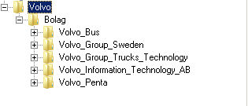

Volvo_Bus_2015-03-20_2015-08-31.xls

Get started – part 1/2

# Import Macro

Start the program “Excel”.

Press ALT + F11 to open “Visual Basic” window.

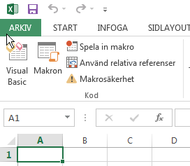

For some reasons when Excel/Office is newly installed you can’t appear the menu “Utvecklare”  
then you need to navigate to \Arkiv\altenativ\ then navigate to “Anpassa Menyflikområdet”.  
Check box “utvecklare” then press OK, you will now have the menu “Utvecklare”

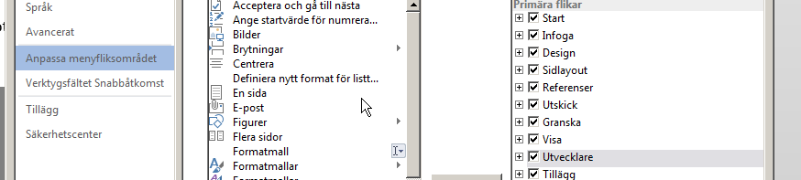

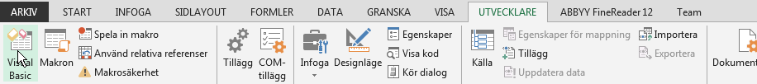  
Press on “Visual Basic“to open the window.

It is now time to import the “*.bas” module, see link below  
X:\Personliga mappar\Daniel\Programering\KUNDER\Volvo_AB

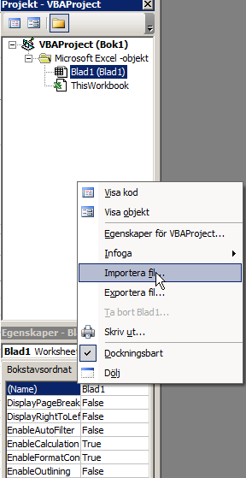

Get started – part 2/2

# Get started

*Create following folders in the structure as the picture below shows anywhere as long you know where.* “\Root”

“\Root\Resources”

All the resource files you need to use as the picture show is located on the link below:

*X:\Personliga mappar\Daniel\Programering\KUNDER\Volvo_AB\resources*

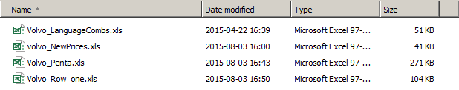

It is very important to have exactly the names as the picture above shows.  
(Except for the company file “Volvo_penta.xls” based on company). The is an example of the folder \Root\Resources\

You save a copy from the downloaded TSP file to “.XLM” because you can bake the macro inside the same file the excel-file for each company and rename the copied file as the examples below:  
  
Volvo_Bus_2015-09-01_2015-11-30 to Volvo_Bus  
Volvo_Group_Trucks_Technology_2015-09-01_2015-11-30 to Volvo_Group_Trucks_Technology  
Volvo_Penta_2015-09-01_2015-11-30 to Volvo_Penta

You need to run each company separate in the folder ”\Root\Resources\” Then merge all rows to one book.

Functions – part 1/6

There are couple of functions you need to run before you get the complete statistics file   
(you also have to check the file for mistakes when done)

# CombineFiles ()

When you run this function, select following folder from the structure you made “\Root\Resources\”.  
The function select all files in the folder then combine them to current workbook also gives each imported file the filename as sheet name except the extension so example “test.xls” result “test”. The function deletes also the sheet named: “Orders”.

GetColData ()

This function it is an array that checks if one of the following sheets exists:  
“Volvo_3P”,” Volvo_Bus”,” Volvo_Business_Service”,”Volvo_Group_Sweden”,”Volvo_IT.

If the sheet exists then copy certain columns from the sheet into the sheet: “Volvo_Statistik”.  
(This is the main reason it is very important to have exactly the following names on the files.)

# myYear ()

The code loops all the worksheets, if the sheet name "Volvo_Statistik" exists, then  
loop all cells in entire column "E". For each cell strip the cell value from left with 6 characters.  
Example 2015-03-31 equals to 2015.

myMonth ()

This code change the format from 2015-02-21 to 02

Functions – part 2/6

CheckInstandCol ()

This function contains two loops the first loop Z That checks couple of statements:  
Ifeach row cell column “H” have value “MLY” then check if column “I” have value “MLY” then  
create a string of the cell in same row but column “A”. Color then the entire row green, also present   
the number of instances in the same row but the cell in column “B”.  
In the next loop “X”, it is almost the same but check instead for the value “IND” then color the entire row yellow.

CheckNumOfIns ()

the first loop "I" checks if the value in every cell in each row column “B” have a greater value than "0" then create a couple of strings on the same row but from different columns. The basic idea behind the math formula it is to use the value from the column "B" (the cell presents the number of instances) divide then the value by the cell in same row in column "AB". There is then a new loop that checks each cell in column "A" every row if the text value is equal to "0" paste then math formula summarize in column "R".

RemIND()  
The code loops all cells in column “H” if the text content is “IND” then delete the entire row.

RemMLY ()   
the function is almost identical to function “RemIND”. The only diffence is check for the value “MLY”.

MyCompany ()   
the code clear the entire column “B”.   
For each sheet in the workbook check for following names (there are more names):  
Volvo_3P, Volvo_Penta, Volvo_Bus, Volvo_Business_Service, Volvo_Group, Sweden,Volvo_IT  
when one of the names are found use the value auto fill all used cells in entire column “B”.

Functions – part 3/6

NewWordsC ()   
this code compare couple statements in two different sheets.  
First loop all cells in column “H” and “I” in sheet “Volvo_Statistik” as long the two text cell values same row are found in the sheet “Volvo_NewPrices” column “A” and “B” same row but the cells can be found anywhere in the sheet as long they are on same row. Then go back to the sheet ”Volvo_Statistik” column “J” multiply the value with the found cells value in sheet “Volvo_NewPrices” but column “G” set the result in sheet “Volvo_Statistik” same row but column “N”.

FuzzyC ()  
This code is very similar to the function “NewWordsC”.  
First loop all cells in column “H” and “I” in sheet “Volvo_Statistik” as long the two text cell values same row are found in the sheet “Volvo_NewPrices” column “A” and “B” same row but the cells can be found anywhere in the sheet as long they are on same row. Then go back to the sheet ”Volvo_Statistik” column “F” multiply the value with the found cells value in sheet “Volvo_NewPrices” but column “K” set the result in sheet “Volvo_Statistik” same row but column “O”.

# RepsandHund ()

This code is very similar to the function “NewWordsC”   
First loop all cells in column “H” and “I” in sheet “Volvo_Statistik” as long the two text cell values same row are found in the sheet “Volvo_NewPrices” column “A” and “B” same row but the cells can be found anywhere in the sheet as long they are on same row. Then go back to the sheet ”Volvo_Statistik” column “L” multiply the value with the found cells value in sheet “Volvo_NewPrices” but column “D” set the result in sheet “Volvo_Statistik” same row but column “P”.

# ContU ()

The loop “I” if the cell each row column “R” have a greater value than 0 then create variable “myCell”  
also create a variable “myMulti” equals to 42, and “myRes”= myCell * myMulti. Present the new value in same cell “column “U”.

Functions – part 4/6

# myColuZ ()

This function contains two loops (“R” and “S”).  
When you run function do the function first activates the current sheet (“Volvo_Statistik”), give label “ws1”. Then the function call the loop “R” that loops all certain cells for each row (columns “H” and “I”).  
Activate then “Volvo_NewPrices” give label “ws2”, then runs the loop called “S” check in the columns “A” and “B” and if these two cells from loop “R” matches the cells content in columns “A” and “B” “ws2” same row. (see example below)  
”Volvo_Statistik” row 1: column H =”Volvo_NewPrices” row 1: column A content  
”Volvo_Statistik” row 1: column I=”Volvo_NewPrices” row 1: column B contents  
next section of the code is hard to explain, but basically the function creates a couple of variables that the function multiple differently (easier to see in the code) then present the new value in column “Z”.

# myColuAA ()

This function take all the values from 3 different columns and multiply with the old prices in “Kr” then  
-the total cost and put the result in column AA.

Functions – part 5/6

# myContMts ()

Next step is to get **ALL** analyzefiles for every Volvo order and every language file.

You find them in  
[X:\1 Övriga kunder\Arkiv\Originalfiler](X:\\1 Övriga kunder\\Arkiv\\Originalfiler)

We need to prepare all the analyze file names.  
This is an example of a name from an original file “Analyze Files en-GB_ar-SA.xml”.  
Now we need to make the filename is exactly “33823_Analyze_Files_ENG-ARA.xml”  
We will use the program Rename-it I have created a filter to rename all the 40 language combinations:   
X:\Personliga mappar\Daniel\Programering\KUNDER\Volvo_AB\LanguageCombs.rit  
you need then to create following folder on this location C:\data you could also create folder insided and call the folder “used xml files” because the function can approximately run 150 max xml at the time.  
Then the function stops (I am not sure why I believe it’s a Memory dump problem or something), so my suggestion it: don’t have more than 150 files in data folder then add more when you see the function have run through all of them and its values in column “M”

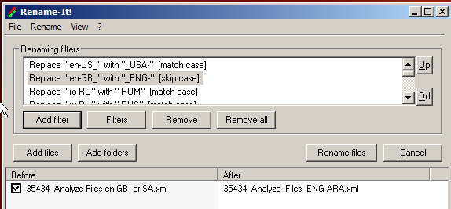  
I first activate the current workbook and give the label “wb” then I run loop “i” that loops through each row. The idea behind the loop it is to recreate the filename then open each “*.xml” file with excel and give the opened workbook label “wbt” gather data from the file close, next file.

I have created a couple of variables from cells the same row this is how I recreate the filename in the workbook “wb”  
myCell =35434 (example of an order number)   
myAnalyzF=”_Analyze_files_”  
mySoLang=Source language (example (ENG))   
myHyph=”_”  
myTarLang=Target language (example (ENG))   
myExt=”.xml”  
I create one string by using all these strings the result can be example:   
“33823_Analyze_Files_ENG-ARA.xml”.  
The runs loop “N” for each active sheet used range check for the text content: “/batchTotal/analyse/inContextExact/@words/#agg" when found we know which column the text content is, then is the next step actually to find the “context match” I runs then another loop “X” for each cell same column if the value is equal “0” copy or if the cell value is greater than “0” then copy. Activate wb workbook paste same row but column “M” close “wbt” and so on. The reason to I want to copy the the value equal to “0” from the xml file it is because we know then the analyze file exists.

Functions – part 6/6

# myCMDiff ()

This function is constructed very similar to the function “myContextMts”  
First loop all cells in column “H” and “I” in sheet “Volvo_Statistik” as long the two text cell values same row are found in the sheet “Volvo_NewPrices” column “A” and “B” same row but the cells can be found anywhere in the sheet as long they are on same row. Then multiple the cell ws1 column “M” with the cell value in ws2 column D and place new the value in ws1 column “Q”.

# ConvToNum ()

This function converts following values from certain columns “N”,”O”,”P” and “Q” to regular numbers

# noAnFiles ()

This code loop every row, if the text-content in column “Q” is “0” start loop in column “M” then if the cell is empty color cell red.

# myColAB ()

Each letter in the array (N, O, P, Q, R, S, T, U, V, W, X, Y).presents a column, the loop loops through all the columns each row and for each cell in all certain columns summarize the cells to a total and present the new value in column “AB” same row.

# ColorNegativeVal ()

This code loop every cell in column “Z” each row and if the cell value is less than 0 then color it 3

# InsertFirstRow ()

This code selects the first row in the sheet “Volvo_Row_One”, then copying  
select sheet “Volvo_Statistik” paste first, also removes color of the row.

# FillEmptyCells ()

Each letter in the array (Q, R, S, T, V, W, X, Y).presents a column  
and for each empty cell fill the cell with value 0

Finalize

Volvo want to have the statistics monthly so give the certain name of the finalized file.

Note!  
Don’t forgot to remove the .bas file from the visual basic for applications.  
Also don’t forgot to remove other sheets:   
(“Volvo_NewPrices” (Company name sheet example: Volvo_Information_Technology_AB”))  
”Volvo_LanguageCombs”,”Volvo_Row_one”)

The only sheet that will exists its “Volvo_Statistik”.

“CompanyName_Month_Year”

Volvo_Penta_01-2015